# COMP3500: Memory Management Part 1

**Exercise 0 (Plickers):** The average wait time is:

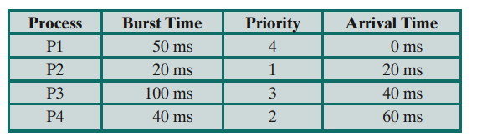

A. 17.5 B. 20 C. 25 D. 32.5

**Exercise 1:** Please rank and compare registers, primary memory, and disks in terms of capacity and speed.

**Exercise 2:** List two or three functionalities of the memory management?

**Exercise 3:** What are pros and cons of the best-fit strategy?

**Exercise 4:** What are pros and cons of the worst-fit strategy?

**Exercise 5:** What are pros and cons of the first-fit strategy?

**Exercise 6:** What are pros and cons of the next-fit strategy?